**Math 155, *Lecture Notes- Bonds* Name____________**

***Section 9.9*** *Representation of Functions by Power Series*

In this section, we will consider a few interesting techniques that will allow us to find a power series that represents a given function. In particular, we will focus on using the formula for the sum of a convergent geometric series to define a power series representation of a particular function. If needed we can move the center of the series, we can perform algebraic operations with a series, or combinations of series, or we can use calculus based operations like differentiation, or integration to create a particular series representation of a given function.

From Section 9.2, we can recall the following theorem:

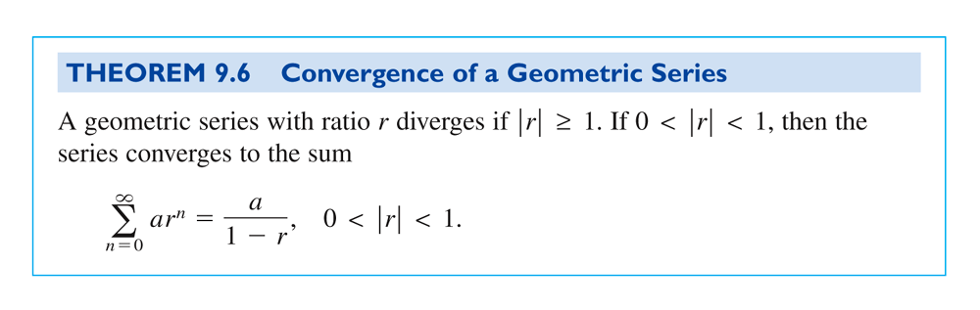

**Ex. 1:** If we let  and  , the geometric series sum formula gives us a power series representation for  centered at .

That is, , for . This series converges absolutely on .

We will use this geometric power series sum formula to develop many other representations of functions by manipulating values of , , and .

**Ex. 2:** Use the geometric series sum formula to represent  as a power series centered at , and find the domain of this power series function.

When we change the center of this power series, we should see , which will show the new center at . Also, we will be able to find a corresponding change in the domain of the power series representation, since we will be moving the center of the previous interval of convergence, .

More Ex. 2:

**Ex. 3:** Use the geometric series sum formula to represent  as a power series centered at , and find the interval of convergence (domain) of this power series function.

More Ex. 3:

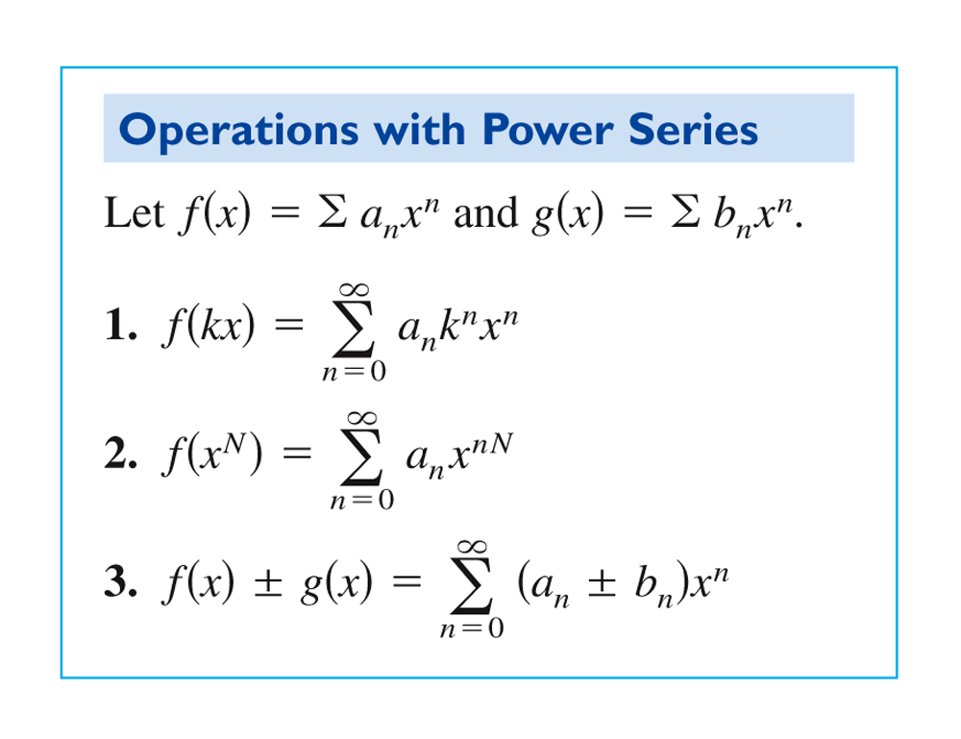

NOTE:

- For simplicity, the properties are stated for series centered at .

- These operations can change the interval of convergence.

- When two series are summed, the interval of convergence for the sum is the intersection of the intervals of convergence of two original series.

**Ex. 4:** Use the geometric series sum formula to represent  as a power series centered at , and find the interval of convergence (domain) of this power series function.

More Ex. 4:

Still More Ex. 4:

Even More Ex. 4:

**Ex. 5:** Use the geometric series sum formula to represent  as a power series centered at , and find the interval of convergence (domain) of this power series function.

More Ex. 5:

Still More Ex. 5:

**Ex. 6:** Use the geometric series sum formula to represent  as a power series centered at , and find the interval of convergence (domain) of this power series function.

More Ex. 6:

Still More Ex. 6: